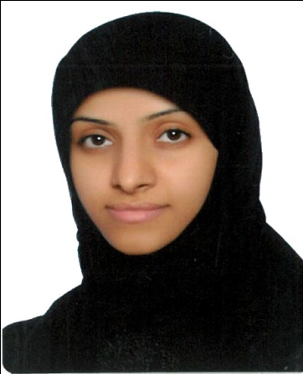**CURICULLUM VITAE**

**Personal Details:**

* **Name: Zainab Fayez Abdulla Mohammed**
* **CPR Number: 871106477**
* **Date of Birth: 02/11/1987**
* **Material Status: Married**
* **Address: House:503 - Road: 2617 - Block: 1026 - Karzakan**
* **E-mail:** [**Baneen.m4@gmail.com**](mailto:Baneen.m4@gmail.com)
* **Telephone: 39016589 – 39203632**

**Education Qualification:**

* **University of Bahrain: BS.C in Computer Engineer (January 2011)**
* **Regal Gulf Training Center: MCSA Certified from Microsoft (January 2016)**
* **Human Performance Improvement Institute: ICDL (January 2019)**

**Training:**

* **Electricity and Water Authority: two months (I worked with them on Virtualization and Firewall project)**

**Skills:**

* **Time management and multi task**
* **Excellent communication skills**
* **Team-working skills**
* **Hard worker and enthusiastic**
* **Highly motivated to improve and developing self**

**Language:**

* **Arabic**
* **English**